**MAKE YOUR TRIP**

Kanini Tourism website – Make Your Trip is a tourism ticket booking platform for the user and the agent can add packages and the admin can add image galleries and accept and decline the registration request of the agent and there is a feedback form where anyone can text their queries and that will be automatically sent to the mail

**DB SCHEMA:**

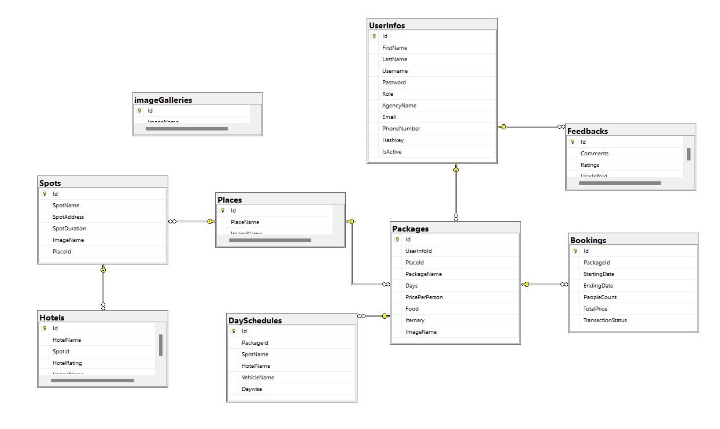

There are 3 flows in this project

* User Flow
* Agent Flow
* Admin Flow

**USER FLOW:**

Here User can book the package based on the particular place and the user can see the package details like Spot details, Hotel details and travelling vehicle details and then the user can book the package after paying the price and the booking details will be downloaded as pdf automatically

**AGENT FLOW:**

Here agent can add packages and the details of the daywise activities , hotels and vehicle details

**ADMIN FLOW:**

Admin can add the image galleries and accept or reject the registration request of the Agent credentials